Irem Coskun: My responsibility for this week was to make some research about main processor subsystem. This week I mainly focused on processor system on the motor rather than the receiver. For input output operation we decided it is best to use raspberry pi before. This week I investigated the operation that we can accomplish with raspberry pi. This week my main purpose to understand the GPIO operations of the device. We are planning to use pi as a decision unit, and outputs the signal accordingly to the motion subsystem. C++ is used for coding the Raspberry Pi because integration with the codes of the other subsystems will be easier. My teammate Fatmanur Arabacı helped me through this challenging task. We constructed a simple experiment with LEDs in order to use GPIO ports. We accomplished this task so, we can say that we have control over main processor system. The connections between other systems will be covered next week. Also, we are not constructed our algorithm fully. But, to sum up it is going to take the signal from its input ports and gives output according to the input ports that have signal. Main challenge we faced was to connect pi with Ethernet port. We are planning to use Raspberry Pi 3 with Wi-Fi connection but since we do not have it right now we used one of our member Aycan Beyenir’s Raspberry Pi 2 which does not have a Wi-Fi connection. Figure **XXXXX** below shows a picture of Raspberry that we are planning to use and continue our trials.

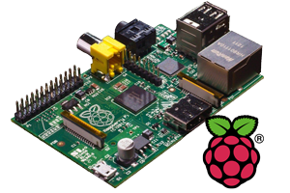

Figure 1 : Raspberry Pi